Annual Report 2022-2023 of the CHHA Vancouver Branch
CHHA Vancouver is a self-help, consumer group which provides advocacy, support and educational activities for successful living with a hearing loss. While the COVID pandemic has impacted our in person activities, we remain actively engaged in hearing loss issues at national and local levels and continue to reach out to our membership.
Walk2Hear
This past fall, the CHHA Vancouver Walk2Hear returned in person for the first time since the beginning of the COVID pandemic. It was our 13th annual Walk2Hear, and the seventh year that we have used the CanadaHelps platform. The fundraising campaign closed on October 31, 2023 with $2,315.00 raised.
The fundraising campaign culminated in a gathering at Jericho Beach Park on Sunday, September 17, 2023. It was a sunny day but not too hot due to some light cloud cover. Participants mingled with one another, reconnecting with old friends and meeting new friends after years of social distancing and Zoom webinars.
A large banner promoted the Accessible Navigation to Employment (ANTE) program, which is operated by CHHA National in partnership with Mohawk College. Volunteers at the registration table distributed ANTE program materials and briefly explained the ANTE program.
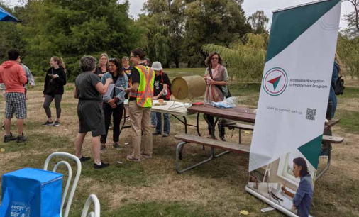
The only fly in the ointment was when the battery for the CART display started to beep ominously during event setup. Unfortunately, the battery could not be restarted, therefore it would be impossible to display CART on a large screen as originally planned. Catherine Siegler and Rosalind Ho hastily put their heads together to come up with a solution. Rosalind was able to set up a hotspot from her smartphone, so that Catherine could broadcast CART via a Streamtext link. Catherine and Rosalind then quickly distributed the Streamtext link to attendees via text message.
After welcoming everyone and very important stretches, led by Naghmeh Samenirad, participants set out to walk a 2 km loop around the park.
Awards were distributed at the closing ceremony. Ruth Warick was the top individual fundraiser. Wavefront Centre for Communications Accessibility was the top fundraising team. Draw prize winners were: Kyran Steuart, Lily Lam, and Teresa Hemsing.
Many thanks to our event volunteers: Amy Ho, Cheryl Marr, Edward Tran, Roxana Naseri, and Teresa Hemsing!
The Walk2Hear event was made accessible with CART and ASL interpreting.
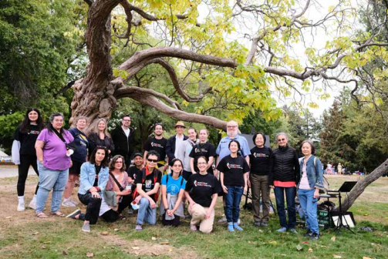
Educational Programs
CHHA Vancouver and CHHA-BC jointly hosted a series of monthly webinars, held online via Zoom. All webinars were made accessible with CART and ASL interpreting.
World Hearing Day 2022 — Hearing Care For All
CHHA Vancouver partnered with Wavefront Centre for Communication Accessibility and the CHHA BC Chapter to host a webinar to celebrate World Hearing Day on March 7, 2022. Dr. Ruth Warick, who is the Director of Programs and Services at Wavefront, moderated the workshop.
Panel speakers from Wavefront and CHHA-BC shared hearing loss statistics and suggestions on how to improve hearing care for all:
The speakers emphasized that hearing loss impacts one’s mental and physical health; and so, regular hearing care should be a part of regular healthcare, not brushed aside as a luxury. Client-centred hearing health care should cover both hearing care technologies as well as other communication strategies.
Hugh McCormack shared statistics about the prevalence of hearing loss and tinnitus in the general population, and emphasized the benefits of using your hearing aids and cochlear implants as much as possible. Gael Hanan discussed that there needs to be better societal awareness around hearing loss, improved hearing accessibility and expanded professional hearing health care services. Brenda Poon presented on how to empower primary care providers to be instigators of change in hearing health care practice.
Chris Sutton summarized the formation of the Hearing Health Alliance of Canada, which is a unique partnership never seen before in Canada. Together with all levels of government, the Hearing Health Alliance of Canada has been working to develop a national hearing health care strategy, to remove stigma and barriers, and give all children access to proper and timely hearing screening, diagnosis, and intervention.
Gael had the last word: “make good communication your goal, not just good hearing.”
transportation with seniors and

persons w sa
Officer for Seniors and Newcomers with
mers. Chris has been a strong advocate
implementation of t
TravelSmart, sharing information about m
holds a degree in
modal transportation with seniors and
ring information about public transit with
Transportation Access Issues for Hard of Hearing Persons
newcomers. Chris has been a strong adv
ers with diverse abilities, seniors, and
of Victoria and a L
On April 26, 2023, speakers from different backgrounds discussed transportation accessibility issues for for sharing information about public transi
hard of hearing persons.
mers.
specialization in So
customers with diverse abilities, seniors,
• Chris Chan, Manager of Travel Training with Public Affairs, Translink newcomers.
University of British
• Sam Turcott, Executive Lead for Accessibility, BC Ministry of Social Development and Poverty
Reduction,
Spring 2016
• Hans (Uli) Egger, RHFAC Accessibility Certification Specialist, Rick Hansen Foundation
Lorem Ipsum Dolor Spring 2• Derrick Doll, Project Manager, Advanced Listening Systems Ltd
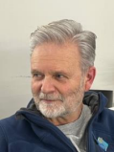
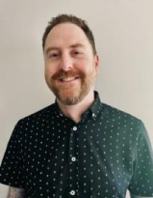
Chris Chan Sam Turcott Hans (Uli) Egger Derrick Doll
Hans (Uli) Egger is the RHFAC Accessibilit
Chris Chan is the Manager of Travel Training
Sam Turcott is the Executive Lead for
Chris Chan outlined accessibility measures on Translink buses and Skytrain, and explained how to
r of Travel Training
Sam Turcott is the Executive Lead for
with Public Affairs at TransLink. Previously, he
Accessibility at BC’s Ministry of Social
summon help in an emergency.
Certification Specialist at the Rick Hanse
sLink. Previously, he
Accessibility at BC’s Ministry of Social
was the Transportation Demand Management
Development and Poverty Reduction. Sam a
emand Management
Foundation. He has conducted over 150+
Development and Poverty Reduction. Sam and
his team support government’s efforts to
Sam Turcott outlined the Accessibility Legislation for BC, and emphasized that the best way to put
Officer for Seniors and Newcomers with
his team support government’s efforts to
li) Egger is the RHFAC Accessibility
Derrick Doll is a P
ewcomers with
ratings of various types of facilities and cadvance accessibility and inclusion priorities f
the accessibility legislation into practice is to involve the significant lived experience of persons with TravelSmart, sharing information about multi
rmation about multi
advance accessibility and inclusion priorities for
Listening Systems
sits on the Accessible Standards Canada
disabilities to ensure that there will be “nothing about us without us.”
modal transportation with seniors and
persons with disabilities, including through th
ation Specialist at the Rick Hansen
seniors and
persons with disabilities, including through the
implementation of the Accessible BC Act. Sa
Technical Committee for a model standar
newcomers. Chris has been a strong advocate
Audiology/Hearing
implementation of the Accessible BC Act. Sam
Hans (Uli) Egger shared his background as a person with a spinal cord injury, and the challenges he en a strong advocate
ation. He has conducted over 150+
for sharing information about public transit with
holds a degree in Economics from the Univer
the built environment accessibility. As a p
holds a degree in Economics from the University
faced dealing with hearing loss from a young age. Hans also shared a very useful checklist of what hard
out public transit with
customers with diverse abilities, seniors, and
MacEwen Universi
of Victoria and a Law degree with a
of various types of facilities and currently
who is Hard of Hearing, he also possess
of hearing people should do before they go traveling. Hans also explained the Rick Hansen Foundation
bilities, seniors, and newcomers.
of Victoria and a Law degree with a
specialization in Social Justice from the
Accessibility Certification, which goes beyond the minimal BC building code to certify the level of year’s work experi
lived experience of understanding the
specialization in Social Justice from the
University of British Columbia.
the Accessible Standards Canada
accessibility in the built environment of a given location.
University of British Columbia.
importance of accessibility from a hearing
ical Committee for a model standard for disability lens.
dispensing clinic w
Derrick Doll presented about how Advanced Listening Systems has installed hearing loops at various Practitioner. He als
transportation hubs and routes, such as on 12 BC ferries, and 1-1 hearing loops at the gates in Victoria ilt environment accessibility. As a person
International Airport and Comox Valley Airport. However, North America is pretty far behind the UK or
Hard of Hearing, he also possesses the
Israel in installing hearing loops at transportation facilities.
xperience of understanding the ance of accessibility from a hearing ity lens.
working in the Audievent production a
Hans (Uli) Egger is the RHFAC Accessibility Certification Specialist at the Rick Hansen
Derrick Doll is a Project Manager for AdvancListening Systems Ltd. He has studied
AC Accessibility
Derrick Doll is a Project Manager for Advanced
Foundation. He has conducted over 150+
Audiology/Hearing Aid Technology at Grant
the Rick Hansen
Listening Systems Ltd. He has studied
ratings of various types of facilities and currently
MacEwen University, Edmonton. Derrick has
ucted over 150+
Audiology/Hearing Aid Technology at Grant
sits on the Accessible Standards Canada
year’s work experience in a hearing aid
Description: During this talk, Felicia D’Amato will present on how to set emotional
boundaries and practice self-care in the age of COVID. She will discuss what emotional
boundaries are, how they help us, and how to implement and practice them along with
self-care, while navigating a pandemic.
Communication and Relationships Between Friends/Partners with Hearing Loss
On June 13, 2023, Felicia D’Amato talked about navigating relationships while having a
Felicia D’Amato is a registered social worker in
British Columbia, working at the Deaf and Hard of
hearing loss, covering the following topics: communication strategies, communication
Hearing, and Deaf-Blind Well Being Program in
breakdowns, and introduction to love languages.
Burnaby. She speaks and signs fluently. Felicia has
spent the last 5 years working primarily with adults
and seniors, doing case management, system
Panel of Professionals
navigation, 1:1 counselling, running groups, and providing consultation to hearing professionals around the province. Felicia is passionate about mental health and supporting individuals around BC
On October 30, 2023, Heather Enns moderated a Panel of Professionals workshop to navigate the various systems they are involved
featuring the following hard of hearing professionals:
with. She loves what she does and is always learning
Felicia D’Amato
• Jessica Niemela, Pediatric Audiologist • Robin Sim, Engineer
new things.
• Jen Andersen, Teacher of the Deaf and Hard of Hearing
• Jackie Lindsay, Human Resources Manager
CHHA is a self-help organization of persons with a hearing loss who advocate for hearing accessibility and inclusion.
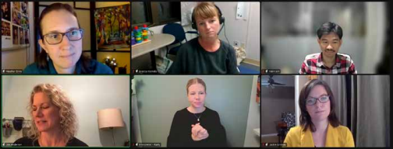
The speakers talked about their backgrounds, detailed their career trajectories, and what their current jobs are like. They also offered tips on how to handle workplace challenges due to their hearing status, when and how to disclose it, and described accessible technologies that help them at work.
Governance
Membership is at 20 persons. An annual report was submitted to CHHA-BC, and members attended the virtual CHHA-BC AGM on May 18, 2023.
Members of the CHHA Vancouver Branch Executive are:
Rosalind Ho, President
Marco Chiaramonte, Vice-President
Naghmeh Samenirad, Secretary
Miron Gazda, Treasurer
Mary-Ann Livesey, Member-at-Large
Heather Enns, Member-at-Large
Thanks go to my colleagues on the CHHA Vancouver Board for their commitment and awesome work. A special thanks to Accurate Realtime Inc. for continued excellent captioning for us. 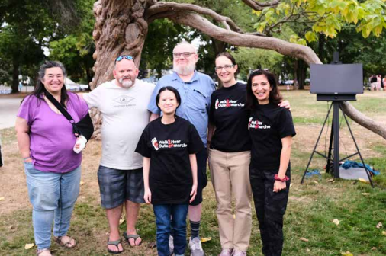
Rosalind Ho, President, CHHA Vancouver Branch
Report respectfully submitted on November 28, 2023

