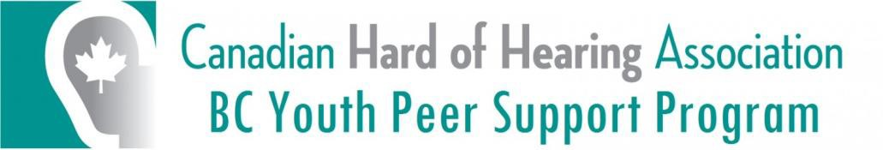

Annual Report 2022-2023
Mission:
To create a platform where hard-of-hearing youth and kids can be empowered to foster active leadership, provide peer support, advocate, and promote hearing awareness in their communities.
Family Weekend Camp 2022:
The family weekend camp was held at Camp Jubilee, located in the Indian Arm near Deep Cove, British Columbia from September 23rd to 25th 2022. The total number of participants was 26. The group consisted of hard-of-hearing children, their parents, siblings, and young adults. The families enjoyed playing board games and participating in archery, beach study, team building games, canoeing, movie night, campfire, and an unplanned talent show.
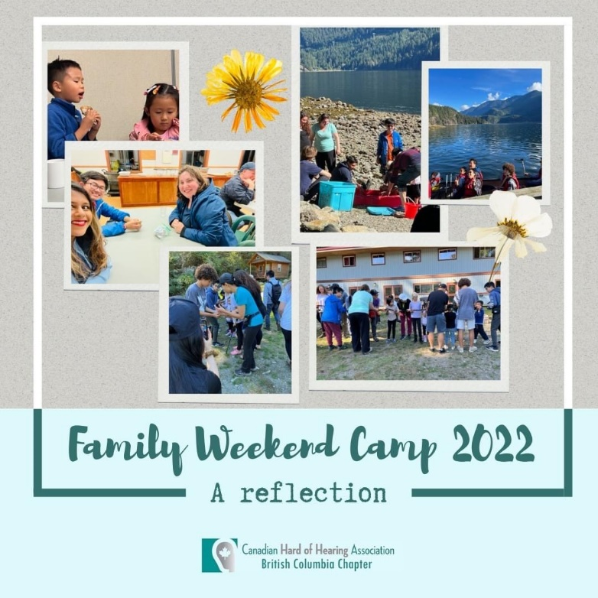

YPSP Holiday Party
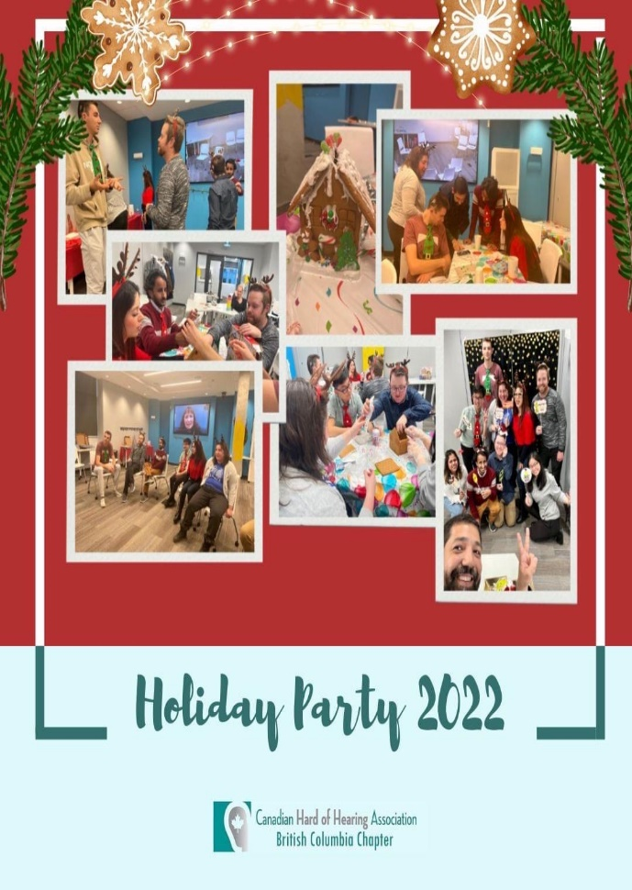
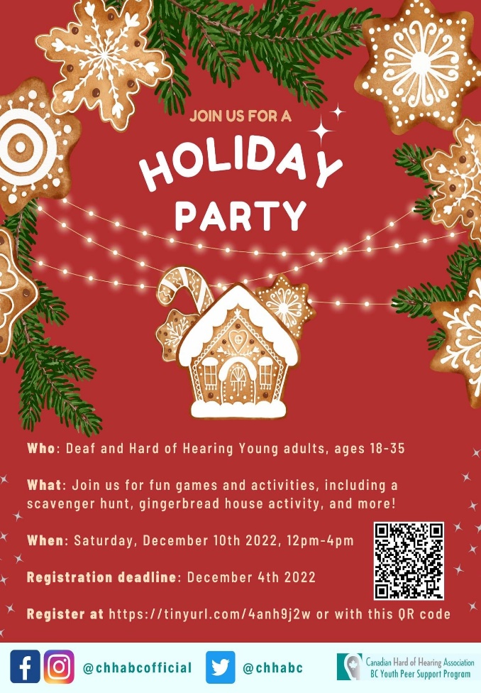
On December 10th, 2022, CHHA BC hosted the very first-holiday party for hard-of-hearing youth at the conference hall of the Wavefront Centre for Communication Accessibility. The event was organized for promoting social interactions and friendships of hard-of-hearing youth as part of The Youth Peer Support Program. This event brought nine hard-of-hearing youth together in an inclusive platform to share holiday vibes with each other.

YPSP Coffee Date
On March 25th, 2023, CHHA BC Chapter hosted a coffee date for hard-of-hearing young adults at Waves Coffee House, New Westminster. The coffee date was organized to meet hard-of-hearing young adults and create an inclusive platform to promote social interactions and novel friendships within the group. This event brought six youth together to share the 2023 spring time splendour with positive vibes. The young adults were served hot beverages and scrumptious treats of their choice during the chit-chats.

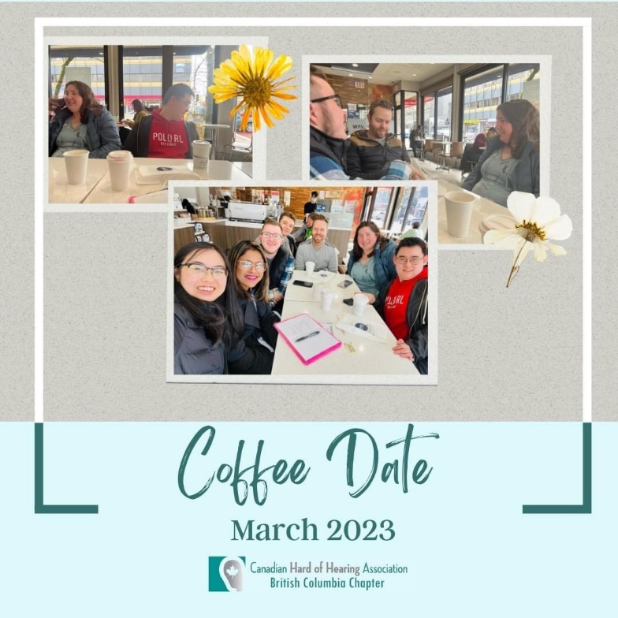

Planned Activities for the Rest of 2023
The upcoming activities are a YPSP day out on May 27th, an online awareness event on June 24th, July 22nd family Picnic, and the family weekend camp from September 15th to September 17th, 2023.
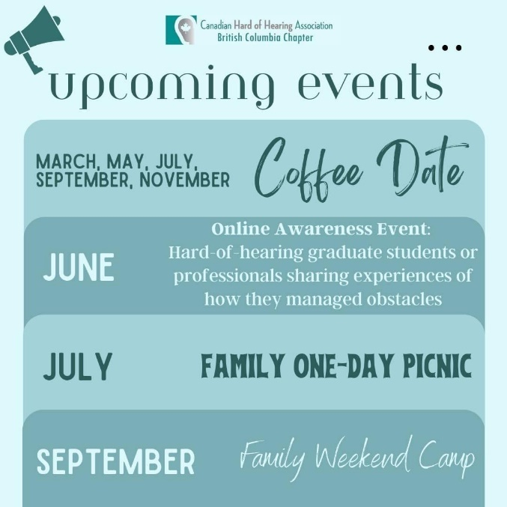

Online Awareness Event- June 24th, 2023
We are pleased to host an online networking event for hard-of-hearing graduate students and professionals sharing experiences of challenges faced during their daily life to give some idea of what to expect during the post-secondary transition and career.

Family Picnic-July 22nd,2023
We are pleased to inform that a one-day family picnic will be back during summer and we are actively looking for volunteers to be part of the volunteer committee.

YPSP Volunteer Recruitment
CHHA BC has called for applications for YPSP volunteers to assist with the upcoming summer & fall activities.

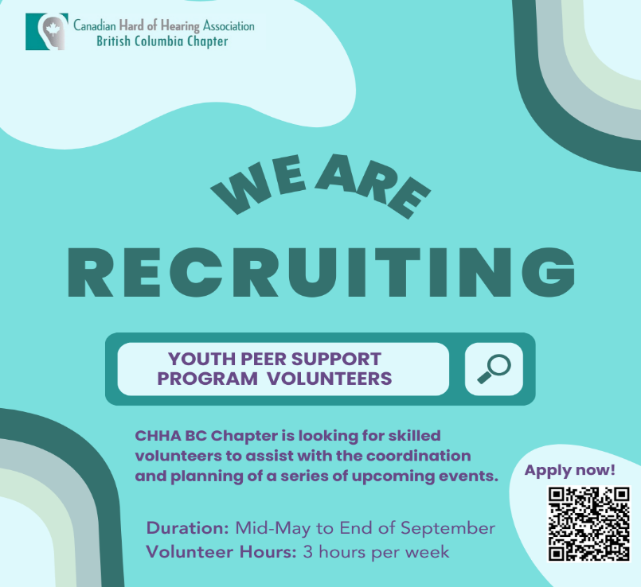

Family Weekend Camp 2023
Family weekend camp 2023 will be held from September 15th to September 17th at Timberline Ranch, Maple Ridge. The camp is aimed to promote social interactions and friendships of hard-of-hearing children their families and hard-of-hearing young adults.
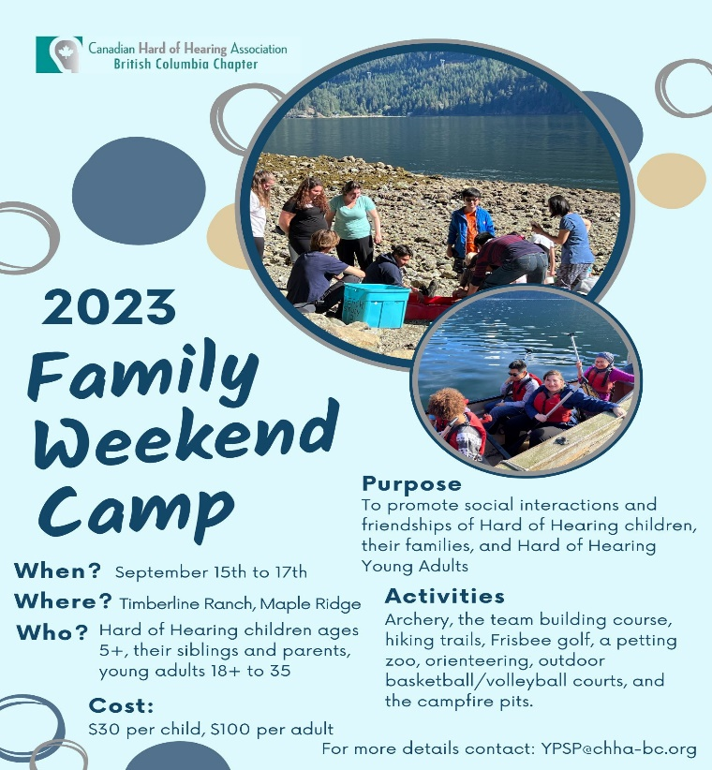

Acknowledgements
We would like to recognize the CHHA BC Board, volunteers, and financial support whose contributions have made all activities possible:
CHHA BC Board
We gratefully acknowledge the financial contribution and support of the CHHA BC Board.
Volunteers
- Vivian Zhang
- Sophia Mincheva
- Tasha Cox
Financial Support
• BC Gaming Grant
• Caldor Foundation
• CHHA Foundation

Respectfully submitted,
Shehana Mirza,
Project Coordinator
May 18th, 2023

